**Technical Documentation – Deploy_RMS**

1. Workflow – Deploys RMS Tomcat Artifacts to an Environment.

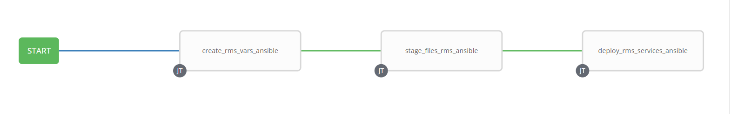

1. Survey – User Supplied Variables

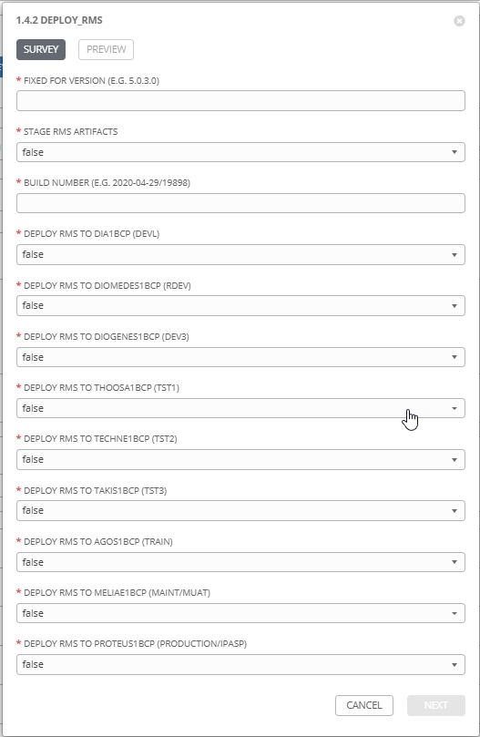

|  |  |  |  |
| --- | --- | --- | --- |
| **Survey Extra Variables** | **Prompt** | **Type** | **Description and Usage** |
| FFV | Fixed For Value | Text | The fixed for value for the deployment – must be for the format ###.###.###.### (i.e. 58.0.12.0). Numbers only with a maximum of 3 digits and there must be 4 sets separated with a ‘.’. Used to create staging and deployments directories. Used by all job templates in the workflow |
| STAGE | Stage RMS Artifacts | Multiple Choice Single Pick | True or false – Copies the RMS Artifacts from the RMS Build Releases Directory to the Staging folder. |
| ReleaseDir | Build Directory | Text | The /pencmw_common/RMS/releases/ subdirectory that contains the RMS artifacts (eg. 2020-08-12/29) |
| DEVL | Deploy RMS to dia1bcp (DEVL) | Multiple Choice Single Pick | True or false – Deploys the RMS Artifacts to the DEVL Environment on dia1bcp |
| RDEV | Deploy RMS to diomedes1bcp (RDEV) | Multiple Choice Single Pick | True or false – Deploys the RMS Artifacts to the RDEV Environment on diomedes1bcp |
| DEV3 | Deploy RMS to diogenes1bcp (DEV3) | Multiple Choice Single Pick | True or false – Deploys the RMS Artifacts to the DEV3 Environment on diogenes1bcp |
| TST1 | Deploy RMS to thoosa1bcp (TST1) | Multiple Choice Single Pick | True or false – Deploys the RMS Artifacts to the TST1 Environment on thoosa1bcp |
| TST2 | Deploy RMS to techne1bcp (TST2) | Multiple Choice Single Pick | True or false – Deploys the RMS Artifacts to the TST2 Environment on techne1bcp |
| TST3 | Deploy RMS to takis1bcp (TST3) | Multiple Choice Single Pick | True or false – Deploys the RMS Artifacts to the TST3 Environment on takis1bcp |
| MUAT | Deploy RMS to meliae1bcp (MAINT/MUAT) | Multiple Choice Single Pick | True or false – Deploys the RMS Artifacts to the MAINT/MUAT Environment on meliae1bcp |
| IPASP | Deploy RMS to proteus1bcp (PRODUCTION/IPASP) | Multiple Choice Single Pick | True or false – Deploys the RMS Artifacts to the PRODUCTION/IPASP Environment on proteus1bcp |

1. Jobs Used by the workflow - http://owl.penc.local:18080/svn/deploy_automation/trunk/Ansible_PlayBooks/RMS

| **Job Template** | **Ansible Playbook** | **Credential / host** | **Project** | **Description and Usage** |
| --- | --- | --- | --- | --- |
| create_rms_vars_ansible | create_rms_vars_ansible.yml | None – runs on localhost as awx linux user | RMS Deployments | DeploymentLogDir: /codemove_common/dp_automation/deployments/070.000/070.000.009.000/RMS  StageDir: /codemove_common/dp_automation/stage/070.000/070.000.009.000/RMS  date_time: '20200908_1214'  deployment_host: ',diogenes1bcp'  stage_server: diagoras1bcp |
| stage_files_rms_ansible | stage_files_rms_ansible.yml | codemove on {{stage_server}} typically diagoras1bcp | RMS Deployments | Copies RMS Services Artifacts from /pencmw_common/RMS/releases/{{ReleaseDir}} to the {{StageDir}}/{{ReleaseDir}}  The job fails if the /pencmw_common/RMS/releases/{{ReleaseDir}} build directory does not exist.  If the stage_server is set to ‘none’ as opposed to diagoras1bcp, the playbook does not actually do anything, all of the tasks are skipped.  The last task of the job creates a Staging Report in the {{DeploymentLogDir}} in html format. |
| deploy_rms_ansible | deploy_rms_ansible.yml | Pencmw on {{deployment_host}} such as diogenes1bcp – RMS Servers | RMS Deployments | Deploys RMS Artifacts to the RMS environments that have been set to ‘true’ in the User Survey and then restarts the RMS Tomcat Servers.  It also populates an html formatted deployment log {{DeploymentLogDir}}/{{ReleaseDir}}/{{ansible_host}}_RMS_Deployment_Log_{{date_time}}.html |